CS 4701 Project Proposal

Video Neural Style Transfer

**Team Name:** NStylist, **Members:** Roberto Halpin (rgh224), Shirley Thomas (smt244), Meiqi Wu (mw849)

Neural style transfer(NST) is the technique of combining the artistic style of one image to another using deep learning networks. It is one of the most fun techniques in deep learning.

It merges two images, namely the “content” image (Fig 1. A) and “style” image (Fig 1. C), to create a “generated” image (Fig 1. B).

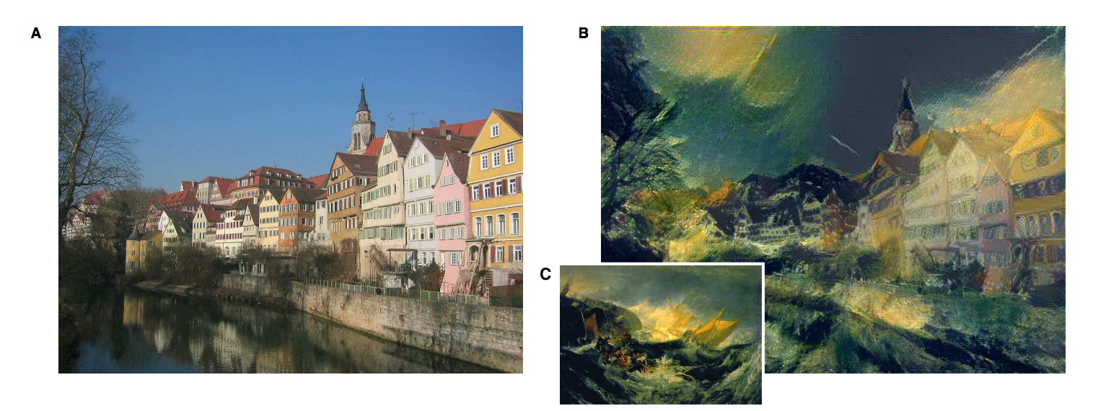

Fig 1. Example of art generation with neural style transfer. (A) “Content” image: photograph depicting the Neckarfront in Tubingen, Germany (Photo: Andreas Praefcke). (B) “Generated” image. (C) “Style” image: The Shipwreck of the Minotaur by J.M.W. Turner, 1805.

In this project, we would be exploring the neural style transfer on videos. Here, we would be taking the style from an image and applying it to a content video to generate a new stylized video. The simple strategy would be to implement the style framewise, but this would bring discontinuities among the frames, leading to an unappealing flickering effect. To remedy this, when training the model, we would be adding consistency loss to maintain the flow of the video.

We target to build a browser based application which allows users to upload any style image and a content video to view a generated video.

For our project, we will be exploring the following aspects of AI: convolutional neural network, deep learning, computer vision, and (maybe) transfer learning.

**Evaluation Criteria:**

**Qualitative evaluation:**

Due to the nature of our project, a main component of the qualitative evaluation condenses into how interesting, or “cool” the generated video appears. It is important that the produced video maintains the structural form of the content video, but also adapts the style from the designated style image. In addition, the generated video should look smooth, it should not introduce unpleasant jaggedness that makes the video unappealing. Clearly qualitatively measuring these characteristics has a great deal of subjectivity, thus in addition to evaluating them ourselves, we plan on showing the generated videos to others. By doing this we can receive a form of user opinion that can give alternative insights. Even though our project mainly consists of qualitative results with no clear, informative quantitative metric, we have some ideas of evaluating our project quantitatively.

**Quantitative evaluation:**

We can quantify the consistency between adjacent images to make sure that the video generated video is smooth across time. For example, we plan to use dynamic range (difference between minimum and maximum pixel values), and correlation between adjacent images, as metrics to quantify the consistency. Another way of quantitative evaluation is to plot the loss function with learning. With a good model, we should see the loss function in a decreasing trend with the progress of training. Most likely the loss function we will use will consist of three terms: content loss, style loss, and consistency loss. Showing the loss values overtime on the trained content video gives an idea of the qualitative characteristics mentioned previously. In addition, we can also show how the loss value deconstructs into the three terms (normalized by any weighting), which gives us a sense of how the model is performing with respect to each characteristic. Lastly, we can take another content video that the model was not trained on, evaluate the model on that content video with the given style image, and find the corresponding loss of the generated video.

**Project Plan:**

|  |  |  |
| --- | --- | --- |
| **Milestone** | **Description** | **Date** |
| Literature & coding review | Read any relevant papers or alternative information sources. Know the basics of the coding languages/frameworks we plan to utilize. | 10/2 |
| Implement basic model | Implement the neural video style transfer frame-by-frame model, most likely on Pytorch. Making sure it can output a generated video given a content video and a style image. | 10/18 |
| Train & evaluate on basic model | Train the basic model, and conduct qualitative and quantitative evaluation on the trained basic model. | 10/25 |
| Status Report | Submit status report | 10/30 |
| Modify model | Consider and implement variants of consistency loss and any other modifications to the base model. | 11/6 |
| Train & evaluate on modified models | Train modified models, and conduct qualitative and quantitative evaluation on trained modified models. | 11/13 |
| Draft design for website/user interface | Design a basic UI to connect to our model. | 11/18 |
| Create website | Create a basic UI for users to upload a style image and content video to view/download the generated video. | 11/25 |
| Qualitative (final) Evaluation | Evaluate application with users | 11/30 |
| Final Report | Finish final report | 11/30 |
| Final Report deadline |  | 12/16 |

**Prerequisites:**

Pytorch is planned to be used for implementing the deep neural network. For the user interface, HTML and javascript can be used.

Extensive dataset is not required. Some sample paintings to study the style (style image) and content videos to transfer the style to, should suffice. The UI will be made flexible to allow the user to input a style image and a content video.

This is not related to any work previously done by any of the members in this team.

**References:**

Leon A. Gatys, Alexander S. Ecker, Matthias Bethge; A Neural Algorithm of Artistic Style arXiv:1508.06576 [cs] (2015). <https://arxiv.org/pdf/1508.06576> ArXiv: 1508.06576.

Leon A. Gatys, Alexander S. Ecker, Matthias Bethge; Image Style Transfer Using Convolutional Neural Networks. In CVPR, 2016. <https://www.cv-foundation.org/openaccess/content_cvpr_2016/papers/Gatys_Image_Style_Transfer_CVPR_2016_paper.pdf>

Manuel Ruder, Alexey Dosovitskiy, Thomas Brox; Artistic Style Transfer for Videos arXiv:1604.08610 [cs] (2016). <https://arxiv.org/abs/1604.08610> ArXiv: 1604.08610.